**DAILY ONLINE ACTIVITIES SUMMARY**

|  |  |  |  |  |  |  |  |  |
| --- | --- | --- | --- | --- | --- | --- | --- | --- |
| **Date:** | **16/06/2020** | | | | | **Name:** | **Archana J C** | |
| **Sem & Sec** | **4th**  **‘A’** | | | | | **USN:** | **4AL18CS011** | |
| **Online Test Summary** | | | | | | | | |
| **Subject** | | **Complex analysis, probability and statistical methods** | | | | | | |
| **Max. Marks** | | **30** | | **Score** | | | **26** | |
| **Certification Course Summary** | | | | | | | | |
| **Course** | **Python and Django full stack web developer bootcamp** | | | | | | | |
| **Certificate Provider** | | | **Udemy** | | **Duration** | | | **2hours** |
| **Coding Challenges** | | | | | | | | |
| 1. Write a C program to remove specific characters in the String. | | | | | | | | |
| **Status: Completed** | | | | | | | | |
| **Uploaded the report in Github** | | | | | **Yes** | | | |
| **If yes Repository name** | | | | | **https://github.com/alvas-education-foundation/archana_j_c** | | | |
| **Uploaded the report in slack** | | | | | **Yes** | | | |

Online Test Details: (Attach the snapshot and briefly write the report for the same)

The online test was from module 1, The test was of objective type questions and there were 30 questions and the duration was 40 minutes. The questions were optimal. The score that I got in the test is 26/30.

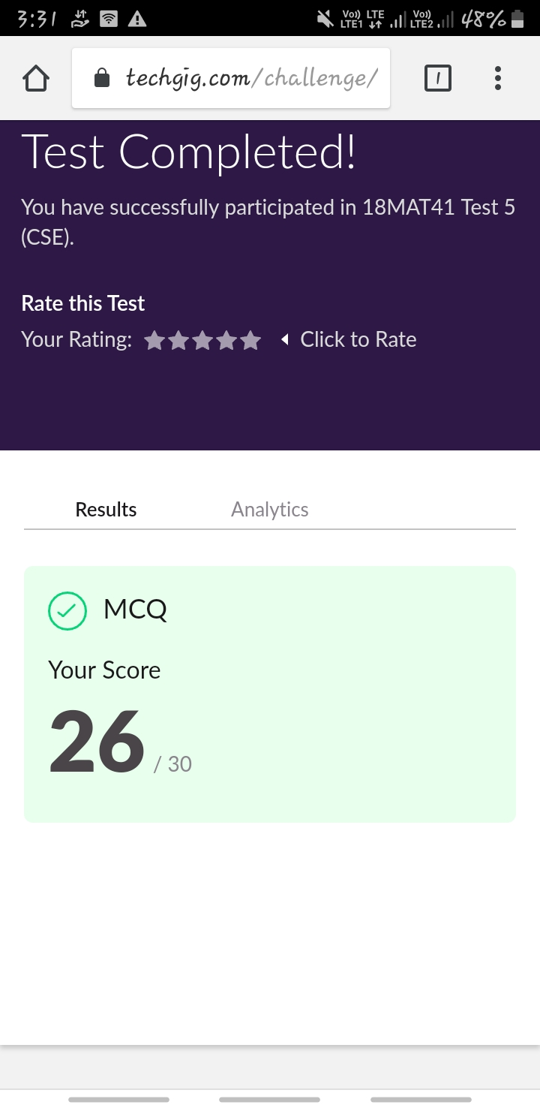

Certification Course Details: (Attach the snapshot and briefly write the report for the same)

COURSE NAME : **Python and Django full stack web developer bootcamp**

CERTIFICATION PROVIDERS : Udemy

The course is all about the web development. I was learnt about html and css, and how to code using html and I’m know in javascript advance.

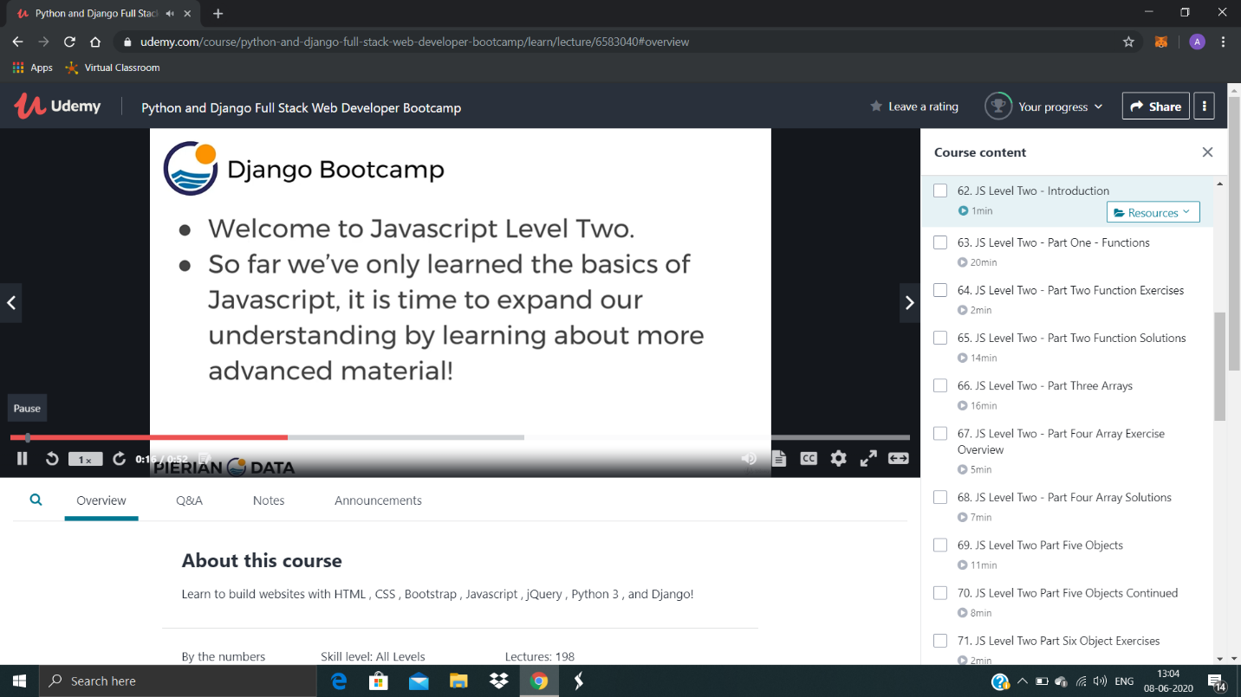

Coding Challenges Details: (Attach the snapshot and briefly write the report for the same)

Today I’m done with some c programs. The solution are already uploaded in github repository

**Program1 :** Write a C program to remove specific characters in the String.

